COVID-19 BANK FACILITIATED PROCUREMENT
Penlon - Emergency Ventilator
Global Offer

Background
Penlon (www.penlon.com) is a worldwide company headquartered in the United Kingdom, focused on the development and manufacture of anesthesia systems and other medical products. They have distribution and service networks worldwide.

The product described below is offered world-wide. Although all offered products are available in all countries, service and training capabilities vary by country. Appendix D includes a list of all countries where Penlon can offer installation and servicing. If your country is not on this list, Penlon will provide training for an in-country representative, as nominated by the Borrrower Country.

Contents
This Offer Summary provides information on Penlon’s Offer and describes the process to accept the offer by completing and returning, to the World Bank, the Registration of Interest (ROI). The following Annexes are attached:
Annex 1 – Penlon’s Product Specifications
Annex 2 – ECRI assessment of Penlon’s ESO2 ventilator
Annex 3 – WHO baseline technical specifications
Annex 4 – Countries with Penlon Distributors
Annex 5 – Ventilator comparison chart
Annex 6 –Clinical Ventilator assessment

The following document is attached to the Offer Summary:
Registration of Interest form

IMPORTANT INFORMATION

The DEADLINE for returning the Registration of Interest to the World Bank is June 16, 2020
Penlon cannot guarantee the lead times beyond the deadline date.

Offered Product:

Penlon are offering the ESO 2 Emergency Ventilator. More details about the ventilator are available in Annex 1. The World Bank engaged ECRI to provide a technical assessment of the ventilator which is provided in Annex 2.

The ESO 2 Emergency Ventilator is a modified anesthesia ventilator that has been assessed as very similar to an intensive care ventilator. ECRI has assessed the Penlon ESO2 as capable of treating COVID-19 patients. The Ventilator meets most, but not all, WHO baseline technical performance specifications for a full intensive care ventilator

Penlon designed and manufactured the ESO2 ventilator in response to COVID-19 requirements of the United Kingdom National Health Service (NHS). A copy of the Clinical Ventilator Assessment commissioned by the NHS is included at Annex 6.

Offer Expiration Date & Process:
This global offer is open until June 30, 2020. Contracts must be signed by this date.

The Borrower country (the Borrower) must confirm to The World Bank their interest in the Penlon ventilator as soon as possible but no later than Tuesday June 16, 2020 and which quantities are needed. Penlon will promptly advise the precise lead time (fitting into their production schedule) and a CIP freight and insurance estimate.

To secure the earliest possible delivery, please signal your interest as soon as you are able. Lead times start from 31 July 2020.

This global offer is open till end June 2020, however lead times will depend on how quickly a final contract is signed.

Other Terms:

Pricing: The price is $11,900. Quoted prices are in US dollars, and include one-year warranty, and are Ex Works since shipping/airfreight costs vary by destination. CIP prices to be established once destination and unit volume established. See below for information on installation, training and servicing.

Payment Terms: 50% of the Contract Price is paid as an Advanced Payment on contract signing, and 50% of the Contract Price is paid on shipping.
Delivery Time: Deliveries will be phased. The earliest possible product dispatch date is 31 July 2020 for orders received in May 2020. Final dispatch dates will be provided upon receipt of the attached Buyer Registration of Interest Form.

Training: User training is included in the price, and is offered either in the UK, in country, by video or video link, or web based using a train-the-trainer approach. UK-based service and user training are included in the purchase price of all countries and exclude costs for travel and accommodation. In-country training may be an option for some countries, which Penlon will confirm upon receiving the registration of interest.
Service: For countries where Penlon has an existing distributer, service during the warranty period will be provided through the local distributer. The list of Penlon distributors is provided in Annex 3.

For countries where Penlon does not have an existing distributer, Penlon proposes to provide service training to the Borrower country, or their designates, to install and provide service. This service training will be facilitated using a train-the-trainer approach, and will be provided either in the UK, in country, by video or video link, or web based. Travel and accommodations to be paid by customer for UK training.
In-country service training may be an option for some countries, which Penlon will confirm upon receiving the registration of interest.

Annex 3 identifies whether Penlon can provide servicing to your country, through their distribution network.

Manuals: Printed user and service manuals will be provided with each piece of equipment. Manuals are available in English, French and Spanish.

Termination for
Convenience: The Borrower may terminate the contract for convenience, at no fault of the manufacturer. If the Borrower does this, they are required to purchase goods that are complete and ready for shipment within 56 days’ notice of the termination.
Borrower and Bank / Penlon Next Steps:

- The Borrower identifies the following on the attached Buyer Registration of Interest (ROI) Form:
  - Quantity of each device required.
  - Single delivery destination.
  - Your country’s accepted contract signing protocols (e.g. e-signature, scanned signature, etc.). Please note that a signature is not required. This request is for the protocol required by your country for signing a contract with the supplier.
- The Buyer Registration of Interest Form must be returned to the Bank by Tuesday June 16, 2020 to allow time for a contract to be signed by Tuesday June 30, 2020.

- Once the Borrower ROI is returned to the Bank, Penlon will confirm specific dispatch times, delivery destination, estimated CIP costs, and training and service details for the Borrower country.
- The Borrower reviews the standard World Bank Facilitated Procurement contract, noting that this contract is not negotiable.

- The Borrower confirms to the Bank if they wish to proceed with an order, the Bank Country Procurement Specialist will finalise the contract for the Borrower with confirmed lead times etc. If the Borrower chooses not to proceed, they need to advise the Bank immediately so available production capacity can be released to another Borrower.
- The Borrower country makes the final purchase decision and must sign the Supplier contract within 5 days from receiving the final contract from the Task Team Leader (TTL).

Annex 1 | ESO2 Ventilator Technical Specification

The Penlon ventilator meets most, but not all World Health Organization and ECRI (www.ecri.org) developed baseline technical performance specifications for a full ICU ventilator that are provided in Annex 3. It is a modified anesthesia ventilator that has been assessed as very similar to an intensive care ventilator. ECRI has assessed the Penlon ESO2 as capable of treating COVID-19 patients.

The table below outlines the offered model, key features, pricing and other contract terms.

The proposed ventilator is similar to an intensive care ventilator and it can operate under the following modes: Volume control, Pressure control, SIMV, SMMV, SPONT and PSV. However, the offered ventilator is limited to a maximum inspiratory pressure of 70 cm H₂O, which is lower than the baseline specification of up to 80 cm H₂O. The ventilator does offer Spontaneous breathing modes but does not allow PEEP in these modes in the same way that is offered by some intensive care ventilators. A more detailed review conducted by ECRI of these performance variances is provided in Appendix B.

It should also be noted that the ventilator is CE marked only. Where applicable, country specific registration has not been undertaken.

Device Models | ESO 2 Emergency Ventilator
Device Models | 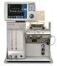
Intended Use | Adult, Paediatric
Modes | Volume Control, Pressure Control, SIMV, SMMV, VC & PC, PSV, SPONT
Tidal Volume | 20 to 1600 mL
Max Inspiratory Flow | 70 L/min
CPAP/PEEP Support | 4 to 20 cm H₂O
Max Pressure Support | 80 cm H₂O
Alarms | Full capabilities
Battery | Rechargeable, 60 minutes
Training | Remote, Onsite, UK-based (varies by country)
Accessories & Options (Included) | Standard silicon autoclavable breathing circuit (#5007473)
Warranty | 12 months
Shipping | Ex Works with CIP estimates to follow
Advanced Payment | 50%
Lead time | Confirmed at time of order  Shipping from 31 July 2020
Price | USD 11,900

Annex 2| ECRI Review of Penlon Ventilator Offer

The demand for ventilators world-wide exceeds the available supply. In response to the scarcity of traditional intensive care ventilators, Penlon proposes a modified anesthesia ventilator to provide many ventilation options and features to treat COVID-19 patients with acute respiratory distress syndrome (ARDS).
The ESO2 ventilator is similar to an intensive care ventilator and it can operate under the following modes: volume control, pressure control, SIMV, SMMV, and PSV. Using the WHO criteria for an intensive care ventilator it lacks the following features:
- Inspiratory pressure up to 80 cm H₂O (ESO2 achieves 70 cm H₂O)
Also, the ventilator does not offer other advanced “intelligent” modes offered by some intensive care ventilators. This ventilator also includes all the necessary alarms for safe patient care.
Based on its technical and clinical review, ECRI believes that the ESO2 ventilator will meet the needs of patients with severe respiratory distress and it can be used to treat COVID-19 patients that require mechanical ventilation.

Annex 3 | WHO & ECRI Baseline Technical Specifications

Ventilators

The World Bank seeks to procure critical care ventilators that meet the following technical specifications. In your proposal, do not include any advanced features or add-ons beyond the capabilities outlined below. Also indicate which accessories/supplies (e.g., breathing circuits) you can supply for one year of continuous use. If additional supplies are needed for continuous operation that you do not provide, clearly indicate this and provide appropriate distributor information, if available.
Technical Specifications
- Compliant with ISO 80601-2-80 and ISO 80601-2-79
- Model must match the voltage and frequency of the purchasing country’s local power grid (e.g., 110-120 VAC at 60 Hz or 220-240 VAC at 50 Hz)
- Tidal volume up to 1000 mL
- Pressure (inspiratory) up to 80 cm H₂0
- Volume (inspiratory) up to 120 L/min
- Respiratory rate (RR): up to 60 breathes per minutes (BPM)
- Synchronized intermittent mandatory ventilation (SIMV): RR up to 40 BPM
- CPAP/PEEP up to 20 cm H₂0
- Pressure support up to 45 cm H₂0
- FiO2 between 21% and 100%
- Inspiratory and expiratory times up to at least 2 sec and 8 sec respectively
- I:E ratio from 1:1 to 1:3
- Air and externally supplied oxygen mixture ratios full controllable
- Inlet gas supply (O2) pressure range 35 psi to 65 psi
- Includes integrated medical air compressor with inlet filter
Modes of Ventilation
- Volume controlled with optional PEEP
- Pressure controlled with optional PEEP
- Pressure support
- SIMV with volume support
- SMMV with volume support

Required Alarm Conditions
If alarms can be silenced, this feature is temporary and clearly displayed on the ventilator’s screen when annunciated
- FiO2, minute volume, pressure, PEEP, apnea, occlusion, high RR, circuit disconnection
Power failure, gas disconnection, low battery, vent inoperative, self-diagnostics

Training and Manuals
- User Training: Supplier shall provide in-person or on-line training adequate to meet the needs of all operators. Training shall be available in English, Spanish and French, and shall be available to users within two (2) weeks of equipment delivery.
- User Manuals: Supplier shall provide at least one (1) user manual for each device purchased. Manuals shall provide guidance on the operation of all features of the purchased device, be provided in at a printed format, and be available in English, Spanish and French.
- Service Manuals: Supplier shall provide at least one (1) maintenance manual for each device purchased. Manuals shall provide at least, equipment schematics, parts summaries, preventive maintenance requirements, and troubleshooting guidance, be accessible in printed formats, and be available in English, Spanish and French.

Annex 4| Ventilator Comparison Table
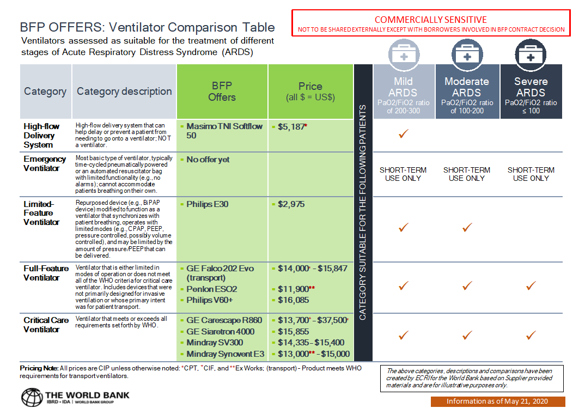

Annex 5| Penlon Servicing

PENLON CAN PROVIDE INSTALLATION AND SERVICING IN THE FOLLOWING COUNTRIES
ALGERIA |  | INDONESIA |  | PHILIPPINES
ARGENTINA (OEM VAP CUSTOMER) |  | IRAN (OFAC) |  | POLAND
ARMENIA |  | IRAQ |  | PORTUGAL
AUSTRALIA / NZ |  | ISRAEL |  | QATAR
BANGLADESH |  | ITALY |  | ROMAINIA
BOLIVIA |  | JAPAN |  | RUSSIA
BRAZIL |  | JORDAN |  | SAUDI ARABIA
BULGARIA |  | KAZAKHSTAN |  | SENEGAL
CAMBODIA |  | KENYA |  | SINGAPORE
CARRIBEAN I. (Spanish Speaking) |  | KOREA (SOUTH) |  | SLOVENIA
CHILE |  | KUWAIT |  | SPAIN
COLOMBIA |  | LEBANON |  | SRI LANKA
COSTA RICA |  | LIBYA |  | SUDAN
CROATIA |  | LITHUANIA |  | SYRIA (OFAC)
CZECH REPUBLIC |  | MALAYSIA |  | TAIWAN
DOMINICAN REPUBLIC |  | MALDIVES |  | TANZANIA
ECUADOR |  | MALTA |  | THAILAND
EGYPT |  | MALYSIA (WEST) |  | TRINIDAD & TOBAGO
EIRE |  | MEXICO |  | TUNISIA
ESTONIA |  | MOROCCO |  | TURKEY
ETHOPIA |  | MYANMAR |  | UAE
FINLAND |  | NEPAL |  | UGANDA
FRANCE |  | NICARAGUA |  | UKRAINE
GEORGIA |  | NIGERIA |  | URUGUAY
GERMANY |  | NORWAY |  | UZBEKISTAN
GHANA |  | OMAN |  | VENEZUELA
GREECE |  | PAKISTAN |  | VIETNAM
GUATEMALA |  | PALESTINE |  | YEMEN
HONDURAS |  | PANAMA |  | ZIMBABWE
HONG KONG |  | PARAGUAY
INDIA |  | PERU

If your country is not on this list, Penlon will train an in-country representative, nominated by the Borrower Country. This may be someone from the Ministry, or an external service provider.

Annex 6| NHS Clinical Ventilator Assessment
